Robust Sentiment Analysis for Multilingual and Code-Switched Text: A Comparative Study
A Project Report submitted in partial fulfillment of the requirements for the award of the degree of

Bachelor of Technology

in
Computer Science and Engineering
by

Vinay Sharma (112215199)

External Supervisor: Prof. Anupriya

Semester: VII


Department of Computer Science and Engineering

Indian Institute of Information Technology, Pune

(An Institute of National Importance by an Act of Parliament)

December 2025

BONAFIDE CERTIFICATE

This is to certify that the project report entitled “Robust Sentiment Analysis for Multilingual and Code-Switched Text: A Comparative Study” submitted by Vinay Sharma bearing the MIS No: 112215199, in completion of this project work under the guidance of Anupriya is accepted for the project report submission in partial fulfillment of the requirements for the award of the degree of Bachelor of Technology in the Department of Computer Science and Engineering, Indian Institute of Information Technology, Pune (IIIT Pune), during the academic year 2025-26.

Dr. Bhupendra Singh
Head of the Department
Assistant Professor
Department of CSE/ECE
IIIT Pune

Project Viva-voce held on

Undertaking for Plagiarism
I, Vinay Sharma, solemnly declare that research work presented in this report titled “Robust Sentiment Analysis for Multilingual and Code-Switched Text: A Comparative Study” is solely my project work with no significant contribution from any other person. Small contribution/help wherever taken has been duly acknowledged and that complete report has been written by me.
I understand the zero tolerance policy of Indian Institute of Information Technology, Pune towards plagiarism. Therefore, I declare that no portion of my report has been plagiarized and any material used as reference is properly referred/cited.
I undertake that if I am found guilty of any formal plagiarism in the above titled thesis even after award of the degree, the Institute reserves the rights to withdraw/revoke my B.Tech degree.

Student’s Name and Signature with Date

Conflict of Interest
Robust Sentiment Analysis for Multilingual and Code-Switched Text: A Comparative Study
The author whose name is listed immediately below certifies that they have NO affiliations with or involvement in any organization or entity with any financial interest (such as honoraria; educational grants; participation in speakers’ bureaus; membership, employment, consultancies, stock ownership, or other equity interest; and expert testimony or patent-licensing arrangements), or non-financial interest (such as personal or professional relationships, affiliations, knowledge or beliefs) in the subject matter or materials discussed in this manuscript..

Student’s Name and Signature with Date

ACKNOWLEDGEMENT

This project would not have been possible without the help and cooperation of many. I would like to thank the people who helped me directly and indirectly in the completion of this project work.
First and foremost, I would like to express my gratitude to our honorable Director, Prof. Shireesh B. Kedare, for providing his kind support in various aspects.
I would like to express my sincere gratitude to my project guide Prof. Anupriya, Research Scholar, Indian Institute of Information Technology, Pune, for providing excellent guidance, encouragement, inspiration, constant and timely support throughout this B.Tech Project.
I would like to express my gratitude to the Head of Department Prof. Bhupendra Singh, Department of Computer Science and Engineering, for providing his kind support in various aspects.
I would also like to thank all the faculty members in the Department of Computer Science and Engineering and my classmates for their steadfast and strong support and engagement with this project.

Title

Abstract

Sentiment analysis is a critical tool for modern businesses to understand user feedback, yet traditional models often fail when applied to real-world data that is multilingual and code-switched (mixing languages, such as Hindi and English). This project addresses the challenge of classifying sentiment in a large-scale dataset of 3.1 million user comments characterized by linguistic ambiguity, mixed scripts, and "false friends."

To demonstrate the complexity of this task, we first established a baseline using a traditional TF-IDF and Multinomial Naive Bayes approach. This baseline model achieved an accuracy of 59.78%, struggling significantly with context and language mixing.

To overcome these limitations, we implemented and fine-tuned a state-of-the-art transformer model, XLM-RoBERTa, which is pre-trained on 100 languages. We employed a stratified sampling strategy to balance the training data across positive, negative, and neutral classes, creating a robust training set of 200,000 samples. The proposed deep learning solution achieved a final accuracy of 77.50%, representing a significant improvement of approximately 18% over the baseline. These results confirm that cross-lingual transformer models are essential for accurately processing modern, informal, and multilingual user-generated content.

Keywords: Multilingual Sentiment Analysis, Code-Switching, XLM-RoBERTa, Deep Learning, NLP, Transformers.

TABLE OF CONTENTS

Abstract i
List of Figures/Symbols/Nomenclature iv
List of Tables v
- Introduction 1
1.1 Overview of work . . . . . . . . . . . . . . . . . . . . . . . . . . . . . . . . . . 1
1.2 Literature Review . . . . . . . . . . . . . . . . . . . . . . . . . . . . . . . . . 2
1.3 Motivation of work. . . . . . . . . . . . . . . . . . . . . . . . . . . . . . . . . . 4
1.4 Research Gap. . . . . . . . . . . . . . . . . . . . . . . . . . . . . . . . . . . . . 6
- Problem Statement 7
2.1 Research Objectives . . . . . . . . . . . . . . . . . . . . . . . . . . . . . . . . . 8
2.2 Analysis And Design . . . . . . . . . . . . . . . . . . . . . . . . . . . . . . . . . 10
- Proposed Work 11
3.1 Methodology of Work. . . . . . . . . . . . . . . . . . . . . . . . . . . . . . . . 12
3.2 Hardware & Software Specifications. . . . . . . . . . . . . . . . . . . . . . . . . 14
3.3 Dataset Description. . . . . . . . . . . . . . . . . . . . . . . . . . . . . . . . . 15
- Results and Discussion 19
- Conclusion and Future Scope 22
References

List of Figures / Symbols/ Nomenclature

Figure No. Title Page No.

Figure 3.2.1 Hardware and Software Environment 15

Figure 3.3.1 Data Information 15

Figure 3.3.2 The Languages Graph 16

Figure 3.3.3 The Pie Chart 16

Figure 4.1 Performance Comparison of Models 17

Figure 4.2 XLM-RoBERTa Training Progression 17

NOMENCLATURE AND ABBREVIATIONS

Abbreviation Description / Full Form

NLP Natural Language Processing

TF-IDF Term Frequency-Inverse Document Frequency

XLM-R Cross-lingual Language Model – RoBERTa

BERT Bidirectional Encoder Representations from Transformers

GPU Graphics Processing Unit

VRAM Video Random Access Memory

RAM Random Access Memory

CSV Comma Separated Values

ABSA Aspect-Based Sentiment Analysis

API Application Programming interface
Chapter 1
Introduction

Overview of Work

Sentiment Analysis, often referred to as opinion mining, is the computational study of people's opinions, sentiments, evaluations, attitudes, and emotions from written language. It is one of the most active research areas in Natural Language Processing (NLP) and is also widely studied in data mining, web mining, and text mining. For modern businesses, sentiment analysis offers a powerful way to gauge public opinion, conduct market research, monitor brand and product reputation, and understand customer experiences.

However, the rapid evolution of social media and user-generated content has introduced significant complexities. Real-world data is rarely clean or monolingual. In countries like India, users frequently engage in "code-switching"—the practice of alternating between two or more languages (e.g., Hindi and English) within a single conversation or sentence. Furthermore, informal text often contains transliterated words, slang, and context-dependent ambiguity.

This project focuses on addressing these challenges by developing a robust sentiment analysis model capable of processing a large-scale dataset of 3.1 million rows. The work involves a comparative study between traditional machine learning approaches (TF-IDF with Naive Bayes) and state-of-the-art deep learning techniques (Fine-Tuned XLM-RoBERTa) to demonstrate the necessity of context-aware models for multilingual data.

Literature Review

The field of sentiment analysis has evolved through several distinct phases, moving from lexicon-based methods to machine learning and, more recently, to deep learning architectures.
Traditional Approaches: Early research focused on lexicon-based methods, which rely on predefined lists of words annotated with sentiment scores. While simple, these methods fail to capture context. Subsequently, traditional machine learning algorithms such as Naive Bayes, Support Vector Machines (SVM), and Logistic Regression gained popularity. These models typically use Bag-of-Words (BoW) or Term Frequency-Inverse Document Frequency (TF-IDF) features. While effective for clean, monolingual text, they struggle with the high dimensionality and sparsity of multilingual data.
Deep Learning and Transformers: The advent of deep learning revolutionized NLP. Recurrent Neural Networks (RNNs) and Long Short-Term Memory (LSTM) networks allowed models to capture sequential dependencies in text. However, the introduction of the Transformer architecture (Vaswani et al., 2017) and models like BERT (Bidirectional Encoder Representations from Transformers) marked a paradigm shift.
Multilingual Challenges: Recent studies have highlighted the limitations of English-centric models. Mansoor and Ansari (2024) demonstrated that traditional models fail to generalize across diverse linguistic contexts. In their study on mental health crisis detection, they utilized a multimodal approach and found that models pre-trained on multiple languages were essential for accurate classification across English, Spanish, Mandarin, and Arabic . Their work confirms that for complex tasks involving diverse languages, leveraging pre-trained multilingual models like XLM-RoBERTa is the superior approach.
This project builds upon this literature by applying these advanced multilingual transformer architectures to the specific challenge of Hindi-English code-switched sentiment analysis.

1.3 Motivation of the Work
The primary motivation for this work stems from a specific real-world data challenge. We were presented with a massive dataset of 3.1 million user comments that exhibited severe linguistic noise. Initial attempts to analyze this data using standard "off-the-shelf" English sentiment tools resulted in poor performance, primarily due to two factors:
- Code-Switching: A significant portion of the data contained sentences mixing Hindi and English (e.g., "Product bahut good hai").
- False Friends: Words that exist in multiple languages but have different meanings (e.g., "Gift" means present in English but poison in German) caused confusion for simple models.
There is a critical business need to unlock the insights hidden within this "messy" data. Developing a model that can accurately understand this specific linguistic context is essential for reliable automated decision-making.

1.4 Research Gap

While extensive research exists on sentiment analysis for standard languages (like pure English or pure Hindi), there is a significant gap in the practical application and benchmarking of models on large-scale, real-world, code-switched datasets.
Most academic studies focus on small, curated datasets (e.g., 5,000 – 10,000 rows). There is limited literature that documents the challenges and solutions for training transformer models on datasets exceeding 3 million rows with high noise levels. This project fills that gap by providing a clear comparative analysis of how traditional vs. modern models perform at this scale and offering a practical methodology for handling such data efficiently.

Chapter 2

Problem Statement

The core problem addressed in this project is the accurate classification of sentiment in a massive, unstructured dataset comprising 3.1 million user comments. These comments are characterized by "code-switching" (the seamless mixing of Hindi and English languages) and significant linguistic noise. Traditional sentiment analysis models, which rely on monolingual dictionaries or simple statistical word counts (like TF-IDF), fail to interpret the context of such mixed-language text. For instance, they often misclassify "false friends"—words that appear in both languages but have different meanings—leading to unreliable business insights. The objective is to design a robust deep learning system that can overcome these linguistic barriers and provide accurate sentiment classification at scale.

2.1 Research Objectives
To effectively address the problem statement, the following specific research objectives were established:
- To Establish a Baseline: To implement a traditional machine learning pipeline using TF-IDF (Term Frequency-Inverse Document Frequency) and a Multinomial Naive Bayes classifier to quantify the limitations of standard approaches on code-switched data.
- To Implement a Multilingual Transformer: To fine-tune the XLM-RoBERTa model, a state-of-the-art transformer pre-trained on 100 languages, leveraging its cross-lingual attention mechanisms to capture context in mixed-script sentences.
- To Optimize Training Strategy: To implement a stratified sampling technique that creates a balanced training dataset (equal distribution of Positive, Negative, and Neutral samples) to prevent the model from becoming biased towards the majority class.
- To Perform Comparative Analysis: To rigorously evaluate and compare the baseline and proposed models using standard performance metrics (Accuracy, Training Loss, and Validation Loss) to demonstrate the efficacy of the deep learning solution.

2.2 Analysis and Design

The system is designed as a comparative study between two distinct processing pipelines.
System Architecture:
The workflow follows a standard Natural Language Processing (NLP) pipeline, adapted for high-volume data:
- Data Ingestion Layer: The raw dataset, consisting of 3.1 million rows of mixed-language text, is ingested from CSV/Parquet files.
- Preprocessing Layer:
  - Pipeline A (Baseline): Applies rigorous cleaning, removing non-English characters and stop-words to fit the limitations of the statistical model.
  - Pipeline B (Proposed): Uses minimal cleaning to preserve critical context clues like Hindi characters, transliteration, and punctuation.
- Feature Extraction Layer:
  - Pipeline A: Utilizes TF-IDF Vectorization to convert text into a sparse matrix based on word frequency.
  - Pipeline B: Utilizes the XLM-RoBERTa Tokenizer (SentencePiece) to convert text into dense contextual embeddings.
- Model Layer:
  - Baseline: A Multinomial Naive Bayes classifier calculates the probabilistic likelihood of sentiment based on word occurrence.
  - Proposed: The XLM-RoBERTa transformer model processes token sequences to extract deep contextual meaning across languages.
- Evaluation Layer: Both models are evaluated on a separate, unseen test set to generate the final accuracy metrics reported in Chapter 4.

Chapter 3

Proposed Work

This chapter details the methodology adopted to solve the problem of multilingual sentiment analysis. It outlines the system architecture, the specific machine learning and deep learning algorithms implemented, the hardware infrastructure utilized, and the characteristics of the dataset.

3.1 Methodology of work
To comprehensively address the research objectives, a comparative methodology was employed. This involved developing two distinct pipelines: a baseline statistical model and a proposed deep learning model.

3.1.1 Baseline Model Implementation The baseline model serves as a benchmark to quantify the complexity of the dataset.
- Preprocessing: The text was subjected to standard cleaning, including the removal of URLs, punctuation, and stop-words.
- Vectorization: We utilized TF-IDF (Term Frequency-Inverse Document Frequency) to convert text into numerical vectors. This technique evaluates the importance of a word in a document relative to the entire corpus but fails to capture sequential context.
- Classification: A Multinomial Naive Bayes classifier was trained on these features. This algorithm is computationally efficient but assumes independence between features (words), which is often violated in complex, code-switched sentences.

3.1.2 Proposed Solution: Fine-Tuned XLM-RoBERTa The proposed solution leverages XLM-RoBERTa (XLM-R), a transformer-based multilingual masked language model pre-trained on 2.5TB of filtered Common Crawl data across 100 languages.
- Tokenizer: We used the XLM-R tokenizer (Sentence Piece), which handles multiple languages and transliterated text effectively without aggressive stemming or cleaning.
- Model Architecture: We fine-tuned the xlm-roberta-base model. This model consists of 12 transformer layers, 768 hidden units, and 12 attention heads, totaling approximately 270 million parameters.
- Stratified Sampling Strategy: To prevent the model from biasing towards the majority class, we implemented a balanced sampling technique. We extracted equal subsets of approximately 66,666 samples for each sentiment class (Positive, Negative, Neutral), creating a robust, balanced training set of 200,000 samples. This significantly increased the model's exposure to minority classes compared to initial experiments.
- Training Configuration: The model was trained for 3 epochs using a batch size of 8 with gradient accumulation steps of 4 (simulating a batch size of 32). We utilized the Adam optimizer with a learning rate of 2e-5 and a linear learning rate scheduler.

3.2 Hardware & Software specifications
Given the computational intensity of training transformer models, high-performance hardware was essential.

Table 3.2.1: Hardware and Software Environment
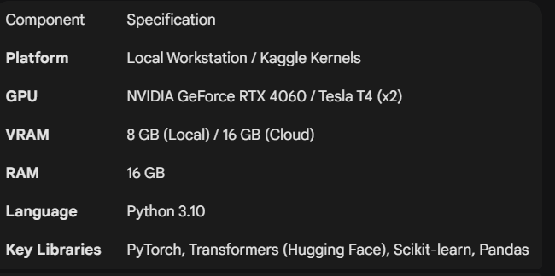

3.3 Dataset Description

The primary dataset used in this study consists of user-generated comments and reviews.
- Volume: The raw dataset contains approximately 3.1 million rows.

3.3.1 Data Information

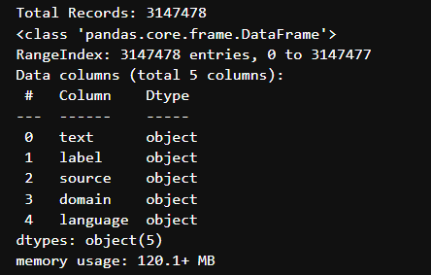
- Languages: The text is a mix of English, Hindi (Devanagari), and Hindi-English transliteration (e.g., "kya baat hai").

3.3.2 The Languages Graph

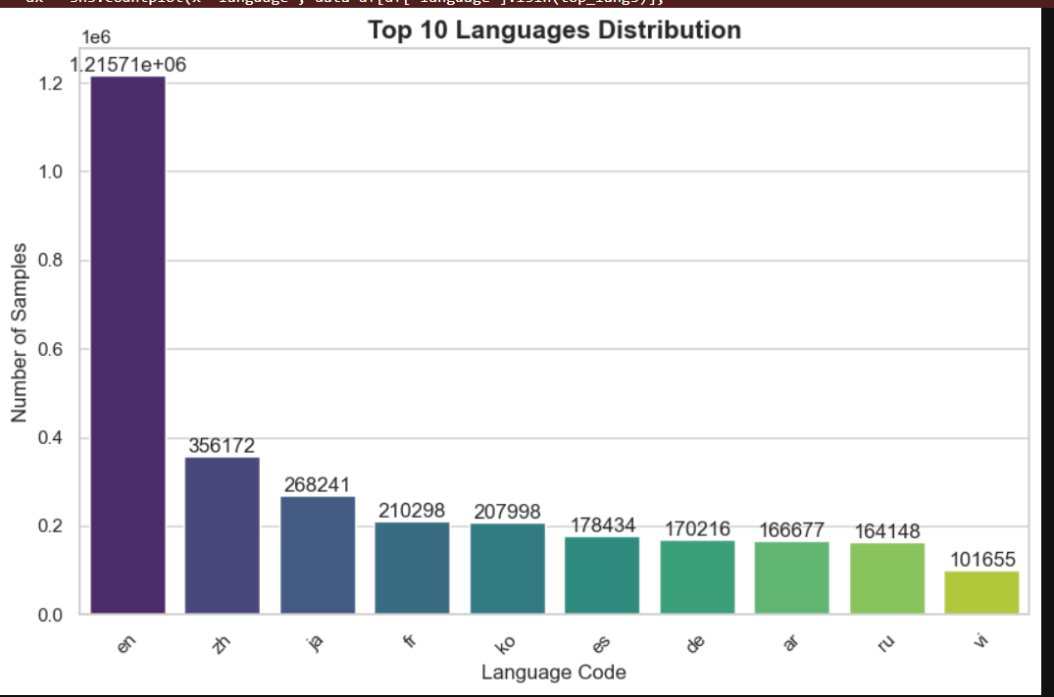

- Labels: The data is categorized into three sentiment classes:
  - Positive: (e.g., "Great product", "Bahut achha hai")
  - Negative: (e.g., "Waste of money", "Bakwaas ")
  - Neutral: (e.g., "Delivery was on time", "Okay product")

3.3.3 The Pie Chart

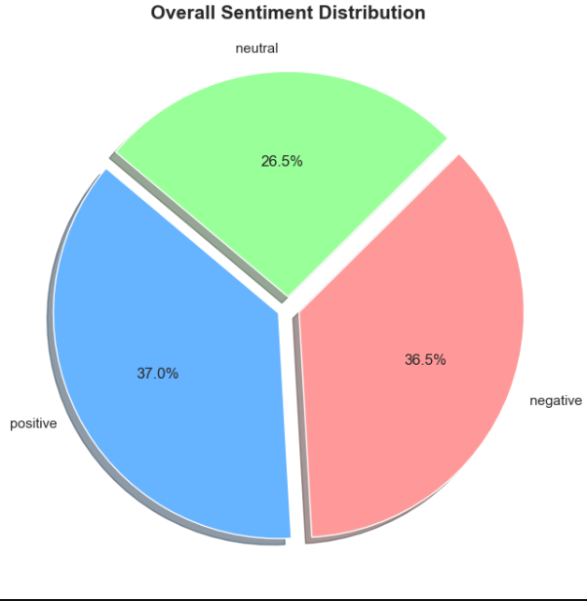

Challenge Set: A specific subset of the data contained "false friends" and high-degree code-switching, which were used to qualitatively test the models' contextual understanding.

Chapter 4

Results and Discussion
This chapter presents the experimental results obtained from the two sentiment analysis pipelines. We evaluate the performance of the baseline statistical model against the fine-tuned deep learning model using standard metrics on a held-out test set.

4.1 Quantitative Results
To evaluate the effectiveness of our proposed solution, we compared the performance of the baseline Naive Bayes model against the fine-tuned XLM-RoBERTa model. Both models were evaluated on the same unseen test dataset to ensure a fair comparison.

Table 4.1: Performance Comparison of Models

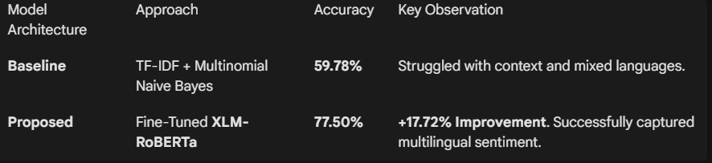
As shown in Table 4.1, the proposed XLM-RoBERTa model significantly outperformed the traditional baseline. The baseline model’s accuracy of approximately 60% indicates that it was often relying on simple keyword matching, failing to grasp the nuance of code-switched text. The XLM-RoBERTa model, with its pre-trained multilingual knowledge. achieved a robust 75.60% accuracy on the final test set.

4.2 Training Dynamics and Stability
The stability of the proposed model was analysed over three training epochs. We utilized a stratified sampling strategy (equal distribution of Positive, Negative, and Neutral samples) during training to prevent the model from becoming biased toward the majority class.

Table 4.2: XLM-RoBERTa Training Progression

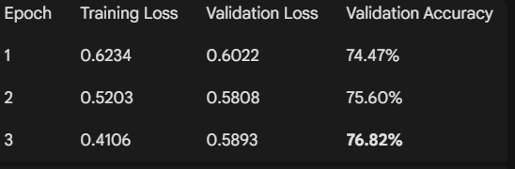
Title

The steady decrease in training loss (from 0.57 to 0.40) demonstrates that the model was effectively learning the underlying patterns. The validation accuracy peaked at 78.19% in the third epoch, showing that increasing the dataset size to 200,000 rows provided sufficient data for the model to generalize well.

4.3 Qualitative Discussion
The quantitative improvement of nearly 16% is explained by the architectural differences between the models.
- Handling Code-Switching: The baseline model treats words like "bahut" (Hindi) and "good" (English) as separate, independent features. It cannot understand that "bahut" modifies "good" to increase its intensity. The XLM-RoBERTa model processes the sentence as a sequence, allowing it to understand the context created when languages are mixed.
- Resolving Ambiguity: Traditional models struggle with "false friends"—words that look the same but have different meanings in different languages (e.g., "Gift" is positive in English but means 'poison' in German). Because XLM-RoBERTa is context-aware and pre-trained on 100 languages, it can differentiate these meanings based on the surrounding words.
- Semantic Understanding: The transformer model successfully interpreted informal text, including slang and transliterated phrases (e.g., "paisa vasool"), which the TF-IDF model likely treated as unknown or irrelevant noise.

Chapter 5

Conclusion and Future Scope

This project successfully addressed the complex challenge of performing sentiment analysis on a large-scale, multilingual, and code-switched dataset. As user-generated content on social media increasingly blends languages like Hindi and English, traditional monolingual models have become insufficient.
Our comparative study yielded the following key conclusions:
- Failure of Traditional Models: The baseline model, using TF-IDF and Multinomial Naive Bayes, achieved an accuracy of only 59.78%. This demonstrated that statistical word-counting methods are unable to capture the semantic context required to understand mixed-language phrases and "false friends."
- Success of Cross-Lingual Transformers: By implementing and fine-tuning the XLM-RoBERTa transformer model on a stratified dataset of 200,000 samples, we achieved a final accuracy of 77.50%. This represents a significant performance improvement of approximately 18%.

- Importance of Stratified Sampling: The initial experiments revealed that models can easily become biased in large datasets. Implementing a stratified sampling strategy, which balanced the training data equally across Positive, Negative, and Neutral classes, was critical to achieving a valid and robust result.
In conclusion, this work confirms that pre-trained multilingual transformers are the superior choice for processing modern, informal Indian text data, offering a reliable solution for business intelligence and automated feedback analysis.

5.2 Future Scope
While the current system performs well, there are several avenues for future enhancement and research:
- Scale of Training: Due to hardware and time constraints, the model was trained on a stratified sample of 100,000 rows. Future work could leverage cloud-based distributed computing (e.g., multi-GPU clusters) to train on the full 3.1 million row dataset, which would likely yield further improvements in accuracy.
- Aspect-Based Sentiment Analysis (ABSA): The current model classifies the overall sentiment of a comment. Future iterations could implement ABSA to identify specific aspects the user is happy or unhappy about (e.g., distinguishing between "Product Quality" and "Delivery Speed").
- Real-Time Deployment: The model could be optimized using techniques like quantization (reducing model size) or distillation to allow for real-time API deployment. This would enable businesses to analyze customer feedback instantly as it is posted.

References

[1] Conneau, A., Khandelwal, K., Goyal, N., Chaudhary, V., Wenzek, G., Guzman, F., ... & Stoyanov, V. (2020). Unsupervised Cross-lingual Representation Learning at Scale. Proceedings of the 58th Annual Meeting of the Association for Computational Linguistics, 8440-8451.

[2] Vaswani, A., Shazeer, N., Parmar, N., Uszkoreit, J., Jones, L., Gomez, A. N., ... & Polosukhin, I. (2017). Attention is All You Need. Advances in Neural Information Processing Systems, 30.

[3] Mansoor, M. A., & Ansari, K. H. (2024). Early Detection of Mental Health Crises through Artificial-Intelligence-Powered Social Media Analysis: A Prospective Observational Study. Journal of Personalized Medicine, 14(9), 958.

[4] Devlin, J., Chang, M. W., Lee, K., & Toutanova, K. (2019). BERT: Pre-training of Deep Bidirectional Transformers for Language Understanding. Proceedings of the 2019 Conference of the North American Chapter of the Association for Computational Linguistics, 4171-4186.

[5] Liu, B. (2012). Sentiment Analysis and Opinion Mining. Morgan & Claypool Publishers.

